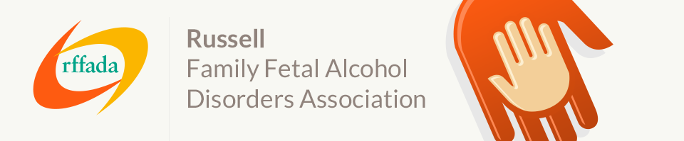

Elizabeth (Anne) Russell –
Founder and Secretary of the rffada 2007 - 2012

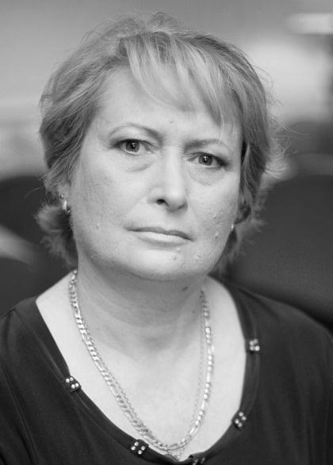
Anne is the biological mother of two adult children with Fetal Alcohol Spectrum Disorder (FASD) and has been in recovery since 19th May 1998. In 2000, Anne found that she had physically harmed her children through her addiction and has since worked to raise awareness in Australia that alcohol and pregnancy don’t mix.
After many unsuccessful attempts to obtain a diagnosis, Dr Clarren from the University of Washington diagnosed Anne’s youngest son Seth with full Fetal Alcohol Syndrome (FAS) and her oldest son Mick with Alcohol Related Neuro-developmental Disorder (ARND). Anne worked for 12 years with NOFASARD as the birth mother contact and has also attended and presented at many national and international conferences and workshops in Australia, New Zealand, Canada and the United States.

On the pathway to learning as much as possible about FASD and finding that there were no books, no resources and very little knowledge here in Australia, she wrote her first book ‘Alcohol and Pregnancy – A Mother’s Responsible Disturbance’ which was published in 2005. Some years later two further books had been written and published, ‘Alcohol and Pregnancy – No Blame No Shame’ and ‘Strategies for Employment Services Specialists – with a particular emphasis on FASD’. In keeping up with technology Anne will shortly release her first and second books amalgamated into an eBook available from ITunes.

In 2007, Anne founded the rffada and in 2010 developed the first publicly available FASD training modules in Australia. Also in 2010 Anne was a finalist in the Australian of the Year awards.

Facebook has provided the rffada with the ability to support parents and carers and raise awareness through this social media. The rffada has three groups on Facebook, one as a general awareness-raising group; the second is a closed group for parents and carers; and the third is for people living with FASD. These groups have been utilised beyond the rffada’s expectations.

Corporate sponsorship from Enterprise Management Group (EMG) allowed Anne to work full time on FASD for 8 months in 2010 and 2011. During that time and after frequent and fervent appeals to Federal and State Governments, she was successful in obtaining funding for NOFASARD from the Department of Health and Ageing. In May of 2011, Anne was employed as NOFASARD’s Executive Officer. After a short term assisting in the set-up of this newly funded peak body, Anne is now working for My Pathway, a multi-million dollar company in Enterprise Development coordinating their FASD projects and writing tenders.

